Topic Six: Rates and Equilibrium

Lesson | Date | Lesson Type | Topic | Text Reference | Syllabus Reference
1 | 2/7 | Theory | Revise Energy Changes and Reaction Rates | 12.1-12.5  13.3-13.4 | 13.10-13.13
2 | 2/7 | Theory | Revise Factors Affecting Reaction Rates | 13.1-13.2 | 13.10-13.13

School Holidays!!!!!!!
3 | 21/7 | Theory | Collision Theory | 13.3-13.4 | 3.14-3.16
4 | 22/7 | Theory | Collision Theory | 13.3-13.4 | 3.14-3.16
5 | 23/7 | Theory | Equilibrium | 14.1 | 13.17-13.18
6 | 23/7 | Theory | Equilibrium in Physical Systems | 14.2 | 13.18, 13.21
7 | 25/7 | Theory | Equilibrium Constants | 14.3 | 13.19-13.20
8 | 28/7 | Theory | Le Chatilier’s Principle | 14.4 | 3.21
9 | 29/7 | Prac | Expt 37 |  | 3.L.1
10-11 | 30/7 | Prac | Expt 38 |  | 3.L.2
12 | 1/8 | Theory | Rates and Yield | 14.4 | 3.20 c), 3.22
13 | 4/8 | Theory | Contact and Haber Processes | 14.5 | 3.23, 7.13
14 | 5/8 |  | Revision
15 | 6/8 |  | Topic Test

Energy Changes

- Use chapter 12 in your textbook to revise energy changes. Write brief notes and do review exercises and questions and problems.

Reaction Rates Revision

- Answer the following questions using chapter 13 of your textbook as a reference.

- Reaction Rates

  - What are the two ways reaction rate can be determined?
  - From your answer to question 1, what are the two formulae that can be used to determine reaction rate?
  - List 5 ways that reaction rate can be increased.

- Collision Theory

  - What are the two things required for a collision to lead to a chemical reaction?
  - What is activation energy?
  - Why doesn’t methane spontaneously combust, despite the abundance of oxygen in the air?
  - In terms of the collision theory, explain each of the 5 ways that reaction rate is increased

- Energy Profile Diagrams

  - Draw an energy profile diagram for an endothermic and an exothermic reaction and explain:
    - What is happening at each stage of the reaction
    - The significance of E_{a} and ΔH for each
  - Do review exercises and questions and problems.

Equilibrium

Many reactions are _______________. As the forward reaction proceeds, the concentration of ______________ builds up which increases the rate of the _______________ reaction. The rate of the forward reaction decreases as the concentration of ______________ decreases.

Once the forward and reverse rates are ______________, and the concentrations of the products and reactants are ______________, a reaction is said to be in ____________________.

Note: The concentrations of the reactants and the products are not necessarily equal.

A graph showing a reaction that goes to completion (all reactants used up).

Draw graphs to show an equilibrium situation where:
- The concentration of reactants is greater than that of products,
- The concentration of products is greater than the concentration of reactants.
Chemical equilibrium exists only is a ______________ system at ____________
_________________.

It is characterized by:

Double arrows are used to signify the equilibrium situation eg:

- Explain why an automatic swimming pool chlorinator that maintains a constant chlorine concentration in the water, is not a true equilibrium system.
- Write the equation for the equilibrium that exists between oxygen and ozone in the upper atmosphere.

Read Text 14.1 and 14.2
Do RE 14.1

Equilibrium in Physical Systems

Use your textbook to formulate notes based on the two questions below.

- Give an example of a vapour equilibrium for a liquid in a closed system, and briefly describe what is happening in the system. Include what happens with a temperature change.

- Give two different examples of solution equilibrium (one molecular and one ionic). Describe briefly for each what is happening in the system including what happens with a temperature change.

Do RE 14.2
Equilibrium Constants

The rate of a chemical reaction is __________________ to the ______________ of the reactants. In an equilibrium system, the rate of the _________________ _________________ is equal to the rate of the _____________ _____________.

The equilibrium constant (K) for the general equation:

aA + bB ↔ cC + dD

Is:

K =

Product concentrations are the numerator, and reactant concentrations are the denominator.

- Write the equilibrium constant expression for the production of ammonia from nitrogen and hydrogen.

- If the equilibrium constant for the formation of ammonia at 470ºC is 0.11, what is the equilibrium constant for the dissociation of ammonia into nitrogen and hydrogen?

Only the concentrations of species in the ____________ phase or ___________ are used.

The equilibrium constant is specific to a particular system and is constant for a ________________________________.

The equilibrium constant gives an indication of the _______________________. High values suggest that products are in _______________________ than the reactants ie. The equilibrium favors the ________________.

- The K values for the ionisation of two weak acids are given:

CH₃COOH ↔ CH₃COO⁻ + H⁺ K = 1.8 x 10-5
HCN ↔ CN⁻ + H⁺ K = 6.2 x 10-10

- Which is the stronger acid?

The equilibrium constant does NOT give any information about the _________ of the reaction.

Read Text 14.3
Do RE 14.3
Le Chatilier’s Principle

Le Chatelier’s Principle can be stated as:

“When a change is made to a chemical system in equilibrium, the system will adjust in such a way as to partially counteract the change.”

To illustrate this, we will look at the equilibrium of NO₂ and N₂O₄ gases (refer to Expt 37).

2 NO_{2(g)} ↔ N₂O_{4(g)} Δ H = -54 kJ / mol

- Temperature

The heat of reaction (ΔH) is required in order to __________ which way an equilibrium will shift after adding or subtracting _____________.

Adding heat will favour the ____________ reaction, in this case the ___________ reaction. Taking heat out (cooling) will favour the ____________ reaction.

Explain why this is the case in regards to Le Chatelier’s principle.

Sketch a graph showing the concentrations of each gas when N₂O₄ is left in a closed container, and then after the mixture is heated. (NB The concentration of NO₂ is slightly higher than N₂O₄ when equilibrium has been reached at room temperature). Describe the observations at each point.

- Pressure

If the pressure of a system at equilibrium is ___________ (or the volume ___________), this will favour the formation of ____________ molecules. Explain why this is the case in regards to Le Chatelier’s principle.

Sketch a graph as described previously, but instead showing the change when the pressure is increased after the system has reached equilibrium.

- What will happen if there are the same number of molecules on either side of the reaction?

- Concentration Change

Describe the effect of adding the following to the equilibrium system shown below:

H_{2(g)} + I_{2(g)} ↔ 2 HI_{(g)}

(i) Adding HI (ii) Adding I₂

For reactions that involve more than __________________ species, the amount of solid or liquid added does not effect the _______________, but changes in concentration of a _______________ substance or amount of _______________ does affect the equilibrium.

Refer to Expt 38 to see the affect of adding acid or base to some equilibrium reactions.

Exercise: Predict the effect on the equilibrium and concentration of all species in regards to the equilibrium of silver solid and iron (III) ions with silver ions and iron (II) ions when:

- Iron (III) chloride is added to the mixture

- Iron (II) sulfate is added to the mixture

- A strip of silver is added to the mixture

- Silver nitrate is added to the mixture

- Something is added to the mixture that reacts with/absorbs the Fe (II) ions.

- Catalyst

Explain why the addition of a catalyst will not affect a system already at equilibrium.

Read Text 14.4

Do R.E.14.4
Industrial Applications of Equilibrium

Industrial processes that involve chemical equilibrium need to maximise ___________ ____________ ______________, but minimise the __________________.

The Haber Process

This is the process for the manufacture of __________________. Ammonia gas is an important substance used in the production of ___________________. This process is named after Fritz Haber, a German Chemist who won a nobel prize for his work in 1918.

The reaction is as follows:

The conditions of the reaction need to be carefully controlled in order to ensure that maximum _________________ is attained for minimum __________.

- Temperature: The reaction is exothermic, which means that ____________ temperatures favour a high yield. However, this means that the rate of attainment of ammonia is quite slow. The temperature used is about ____________________, this ensures an acceptable ______________ for a moderate _________________.

- Pressure: ____________ pressures increase the reaction rate by increasing the ______________ ___________ ______________. The yield is also increased as an increase in pressure shifts the equilibrium to the ______________. High pressures of _______________ atmospheres are used.

- Catalyst: The equilibrium itself is not affected by the addition of a catalyst, however the rate of attainment of equilibrium is significantly increased. In light of this, an _________________________ catalyst is used along with tiny amounts of _________________ and _________________.

Yields of 30-40% are achieved under the above conditions. The ammonia is condensed under pressure and then separated. This removal of the ammonia also assists the forward reaction. How?

Approximately 1000 tonnes of ammonia per day can be produced. The heat released in this ________________ reaction maintains the catalyst temperature. Large amounts of energy are required for the compression of the ammonia gas. This energy is obtained from the reactions used to generate ________________.

** Use the table below to summarise the essential considerations of the Haber Process.

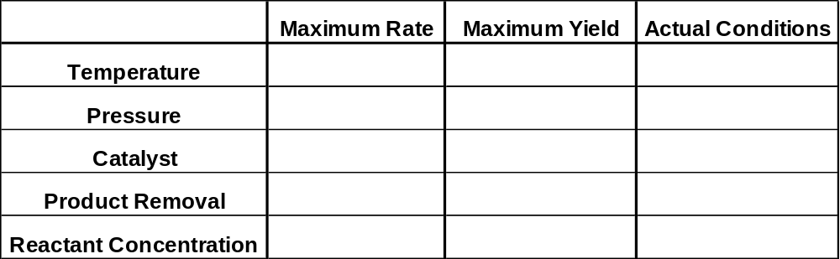
The Contact Process

This process is almost exclusively used for the manufacture of _____________________.

The first step in this process involves the production of sulfur dioxide by burning liquid sulfur according the following reaction:

The sulfur dioxide is then oxidised to sulfur trioxide in the following reaction:

- Temperature: This reaction is ______________, and so ___________ temperatures favour a high yield, but this results in a slow reaction rate. The actual process is carried out at _______________. At this temperature, the reaction occurs rapidly but does not go to completion. The yield is ______________ by cooling the gas mixture to __________ and passing it over additional amounts of ____________.

- Pressure: High pressures would increase both rate and yield, but the temperature and catalyst adequately control these. Therefore the pressure is kept at approximately _________________.

- Catalyst: _________________ is used. This provides a satisfactory rate of reaction, but does not affect the equilibrium yield.

The sulfur trioxide is then absorbed by 98% sulfuric acid to produce ____________, which is effectively 99.5% sulfuric acid:

The oleum is diluted with water to produce 98% sulfuric acid:

This is the concentration of commercial concentrated sulfuric acid, which corresponds to approximately 18M.

Note: The sulfur trioxide cannot be directly added to water, as it is too difficult to handle.

** Use the table below to summarise the essential considerations of the Contact Process.

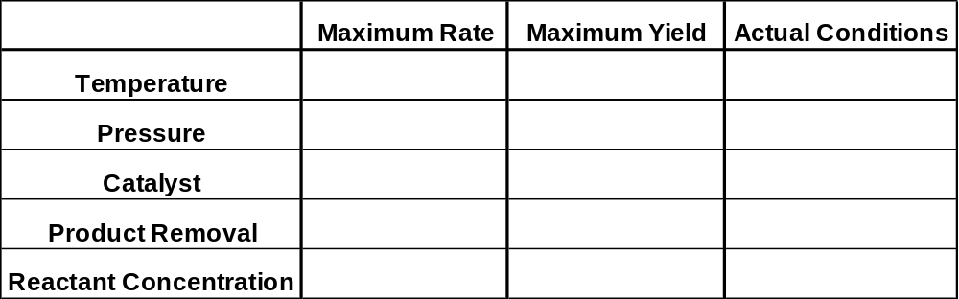

* Read pages 291 – 295
* Do exercise 14.5

* Read pages 345-349
* Do exercise 16.4, Question 4

